**AMIT Learning Center**

**Group M12**

Final project

**Smart Home**

*Presented by:*

*Hussien Yasser Heikal*

*Submission date:*

*1-19-2021*

**DECLARATION**

I hereby certify that this material, which I now submit for assessment on the program of study leading to the award of Diploma in (EMBEDDED SYSTEMS) is entirely my own work, that I have exercised reasonable care to ensure that the work is original and does not to the best of my knowledge breach any law of copyright and has not been taken from the work of others save and to the extent that such work has been cited and acknowledged within the text of my work.

Signed: Hussien Heikal

Mobile No.: 01144451878

Date: January 2021

**ACKNOWLEDGMENT**

I would like to express my gratitude towards the individuals who participated in making this project possible, First of all I would like to thank our family members who provided all the support to make it this far, I would like to thank our assiduous supervisors who provided all the knowledge and guidance, Last but not least I would like to manifest my sincere gratitude towards the AMIT Department's contribution in providing the vital educational needs.

**ABSTRACT**

As the years pass by we tend to rely on Automated machines to carry out our daily life casual activities such as money transactions through ATMs, smart phones, smart gadgets, etc..

Imagine controlling everything around you with a tap on your smart phone, this can be achieved through a dedicated synchronized system that is hardwired to your surroundings such as celling lamps, smart TVs, security systems and much more.

Communication is key, it is much more efficient and effective if all devices communicate together in a synchronized way while sharing information and status makes it easy fast to produce an outcome that will suffice any situation desired.

**1-ARCHITECTURE**

1. Components
2. Methodology
3. Schematic diagram for control architecture
4. Components:

* 2 ATMEGA 32a Microcontroller
* 1 Bluetooth module
* 2 LEDs
* 2 Resistance
* Mobile device

1. Methodology:

The 2 Microcontrollers have a master slave relationship, the master microcontroller receives the user’s desired input from a mobile device through Bluetooth connection then transmits the corresponding data to the slave microcontroller which based on the data it received then turns ON or OFF the corresponding LAMP in either the Kitchen or the Bathroom.

1. Schematic diagram for control architecture:

**Kitchen Lamp**

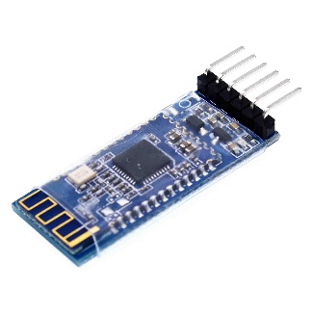

**Slave controller**

**Bathroom Lamp**

**Master controller**

**Bluetooth Module**

**Smart Phone**

UART

SPI

**2-DESIGN**

1. Proteus

1. Master PIN connections

Port D pin 0 connected to TX on Bluetooth module.

Port D pin 1 connected to RX on Bluetooth module.

Port B pin 4 connected to Port B pin 4 on slave controller.

Port B pin 5 connected to Port B pin 5 on slave controller.

Port B pin 6 connected to Port B pin 6 on slave controller.

Port B pin 7 connected to Port B pin 7 on slave controller.

Port C pin 2 connected to Kitchen LED.

Port C pin 7 connected to Bathroom LED.